Enterprise Infrastructure and Networks – IT-520-A

Mallika Regulla

Marymount University

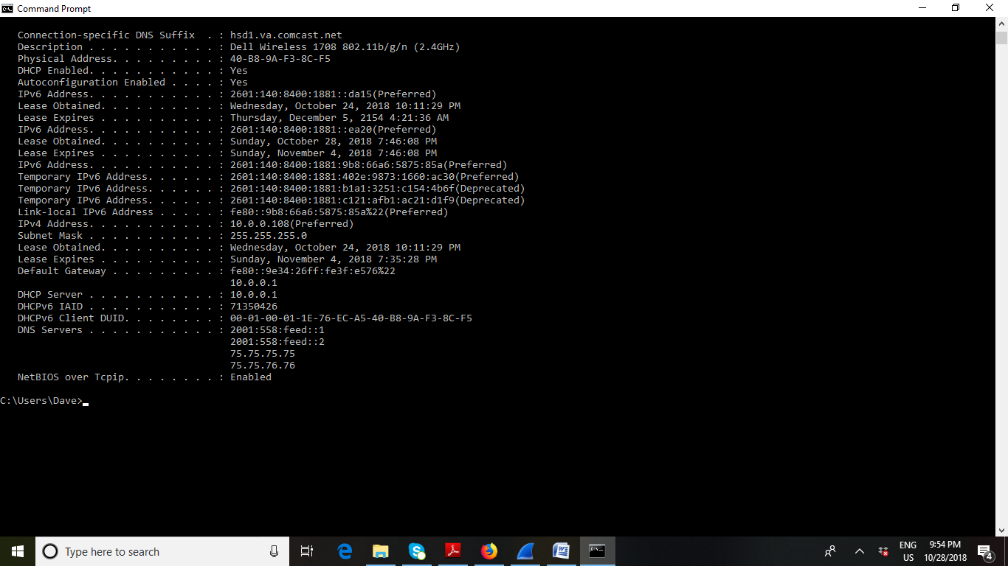

1. MAC address from my computer is 40-B8-9A-F3-8C-F5

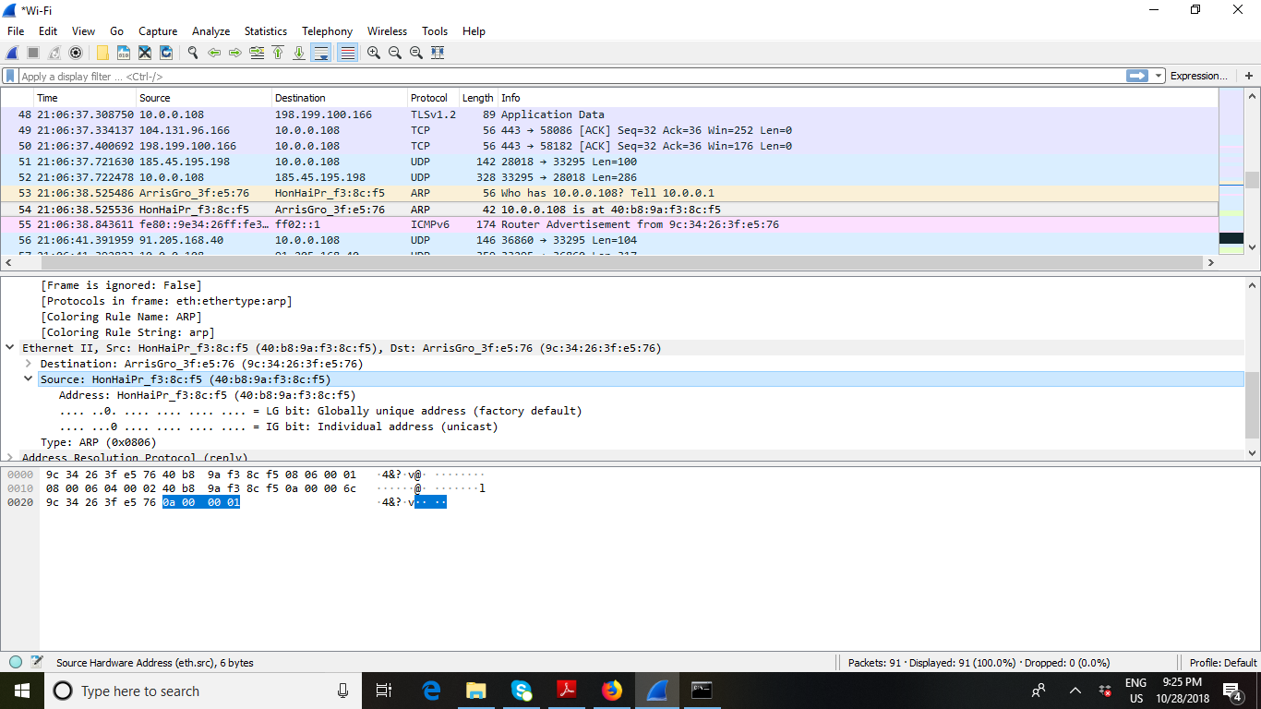

1. Destination MAC address is (9c:34:26:3f:e5:76)

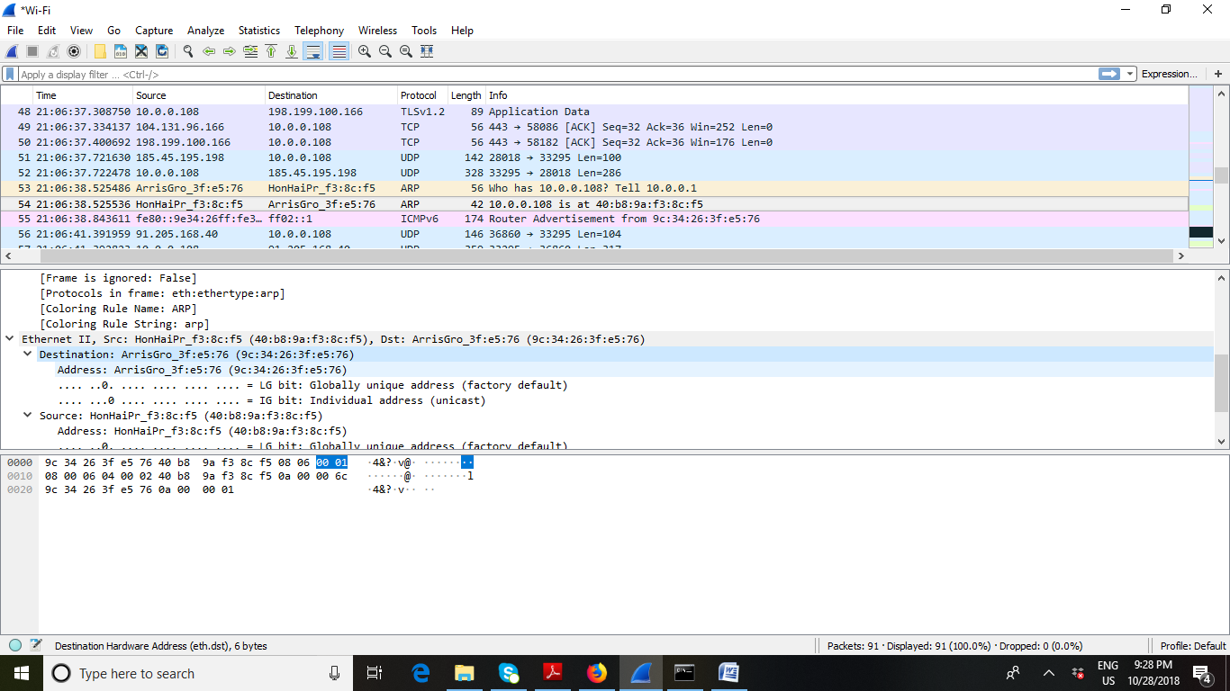

1. This is the address of my router that my computer is connected to.
2. We determine the destination MAC addresses for the given destination IP addresses by using the ARP tables. In other words IP addresses are mapped to their MAC addresses by using the ARP tables.
3. ARP list table, command used is arp -a